Business Requirement Document (BRD)

CR Name: Rewards points
Version: 1.3
PMO ID: -

Revision / Document History:
Ver. | Date | Created by | Sections affected | Reason
1.0 | 02.06.2026 | Mahendra Chavan | - | New requirement
1.1 | 10.06.2026 | Mahendra Chavan | - | New requirement
1.2 | 18.06.2026 | Mahendra Chavan | - | Addition of parameters, Selfi-I to PAS approach
1.3 | 26.06.2026 | Mahendra Chavan | - | Change in login approach and calling of renewal transaction logic

Contents
1. Introduction 3
1.1 Objective 3
1.2 Background 3
1.1 In-Scope 4
1.2 Out of Scope 4
2. Requirement Details 5
• Business Usage: 5
Master Attributes 6
Master Attributes: 7
1. Compliance & Security 16
2. y Requirements 16
3. Non-Functional Requirements 17
4. References 17
5. Requirement Question/ Clarifications Section 17

Introduction

1.1 Objective

- Create end-to-end Wellness Rewards Program for the Health Infinity product, where customers can earn reward points through a Wellness Rewards Platform, and connects with IGI for tracking rewards, validating them, applying discounts, and reflecting the impact on renewal premiums.

1.2 Background

- IndusInd General Insurance Offers Health Infinity product, which includes a Wellness Rewards Program providing discount on the renewal premium based on health-related activities performed by insured members.

The wellness ecosystem consists of:
- PAS – System of record for policy, members, tenure, renewal, endorsements.
- Selfi (IGI) Mobile Application –customer app used for login, activity uploads, dashboards, and data collection.
- Watch Your Health (WYH) – Third-party wellness vendor responsible only for reward point computation from activities and sending and maintaining points on daily basis and share with IGI.

In-Scope

- Master configuration for Product code and Reward points.
- Reward point calculation from wellness activities (Steps, HRA, PRA, Events, Vaccination)
- Vendor → PAS integration
- Member wise login approach
- Member-wise reward calculation
- Storing rewards against member
- Sending rewards point to PAS.
- IGI to store daily rewards points.
- Reward dashboard & reporting
- Reward utilization at renewal
- Endorsement, cancellation, Renewal, split policy, tenure change logic
- Floater & individual policy handling.

Out of Scope

- Other than Health Infinity Product

Requirement Details

  - Purposed Flow:

- Refer below flow chart
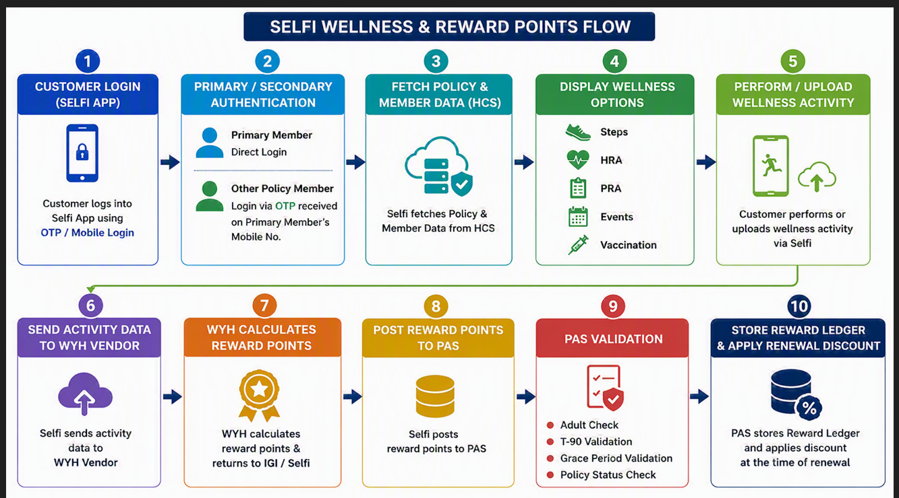

  - Product Reward Configuration Master (Reward Eligibility Master -at IGI):

- Required master to configure which Health products are eligible for renewal discount based on reward points, and to control reward applicability at product level without code changes.

Business Usage:
- Used by PAS during renewal discount evaluation
- Determines whether reward points should be considered or ignored
- Allows product-wise reward enablement

Master Attributes :
Field Name | Description
Product Code | List of product present in PAS
Vendor Code | List of vendor basis on vendor code
Reward Program Applicable (Y/N) | Controls reward eligibility
Eligible Member Type | List of relationship
Renewal Discount Allowed (Y/N) | Controls discount application
Status | Active / Inactive

- The system displays the Product Configuration Master screen.
- The user selects New Product Configuration.
- The user enters the Product Code for which reward eligibility needs to be configured.
- The user enter the vendor code for which reward eligibility needs to be configured.
- The user selects Reward Program Applicable = Yes / No.
- The user selects or verifies the Reward Vendor Code (WYH).
- The user selects Renewal Discount Allowed = Yes / No.
- The user sets the configuration Status = Active.
- The user saves the product configuration.
- System to maintain audit trail for records.
- Once data gets saved data should de display as grid so user can edit and delete the records.

  - Reward Points–Discount Master (Master -at IGI):

- New master required named as “Reward Point discount master” To convert reward points received from WYH into renewal discount percentages.
- IGI will store the daily earned rewards points at backend received from WYH.
- Policy period (1 / 2 / 3 years)
- Product Code
- Reward point range

Master Attributes:
Field Name | Description
Product Code | List of Product
Policy Period (Years) | 1 / 2 / 3
Reward Point From | Lower threshold
Reward Point To | Upper threshold
Discount Percentage | Renewal discount
Effective From Date | Validity start date
Effective To Date | Validity end date
Status | Active / Inactive

- The user selects the Product Code for which the discount needs to be configured.
- The user selects the Policy Period (1 year / 2 years / 3 years).
- The user enters the Reward Point Range (From – To).
- The user enters the applicable Discount Percentage.
- The system allows the user to configure different slabs for different policy periods.
- The system allows the user to configure different discount slabs for different products.
- The user enters Effective From Date and Effective To Date.
- Once data gets saved data should de display as grid so user can edit and delete the records.

  - Self-i App Login:

- Primary Login Flow :
Primary Member (Registered Mobile Number as per policy) to login and attach the policy.

Pre-condition:
- Mobile number must be registered in policy system
- Policy details exist in backend

Steps:
- App Installation
  - User downloads and installs the mobile application.
- Mobile Number Entry
  - User enters Registered Mobile Number (as per policy records)
- OTP Generation
  - System validates mobile number
  - OTP is generated and sent via SMS
- OTP Verification
  - User enters OTP
  - System validates OTP
  - On success → login allowed
- Policy Validation Screen User must enter any of the following:
  - Policy Number / ABHA ID / Address
  - Senior Member DOB (mandatory validation field)
- Policy Mapping
  - System verifies inputs against policy database
  - If valid:
    - Policy is mapped to Primary User
    - UHID(s) associated with policy are linked
- Success Response
  - User is logged in
  - Policy dashboard is displayed

- Secondary Login Flow

Objective:
Secondary Members (family members) to access policy already linked to Primary Member.

Steps:
- App Installation
  - Secondary user downloads the app
- Mobile Number Entry
  - User enters any mobile number (not necessarily registered)
- OTP Generation & Validation
  - OTP sent → user enters → validated → login allowed

- Policy Validation Screen User must enter any of the following:
- Policy Number / ABHA ID / Address
- Senior Member DOB
- Policy Ownership Check
  - System checks: If policy already mapped to Primary Member
- Pop-up Message
"Policy is already attached with mobile number ending ****1401"
- User Consent
  - Prompt: “Do you want to proceed with member login?”
  - Options: YES / NO
- Primary User Authentication
If YES:
- OTP is sent to Primary Mobile Number
- Primary user shares OTP with secondary member
- OTP Validation
- Secondary user enters OTP received from primary
- UHID Selection
- System fetches and displays
- List of insured members (UHID + Name)
- Member Selection
- User selects their respective UHID
- Policy Mapping
- Selected UHID mapped to secondary login mobile number.
- Validations:

- Secondary mobile no. should get stored against the policy member in PAS. Scheduler will be created for sending newly registered mobile no. against the other member.
- *Endorsement should get processed against the policy no. and endorsement letter should get generate ( Need to check for existing process of endorsement, and impact of template and contain of endorsement letter-Consider for Phase II)
- The system shall validate duplicate mobile number authentication.
- If the entered mobile number is already mapped to an existing member under the same policy, the system shall display a message:
- “XXX mobile number is already in use against a policy no.”
- Below are the current parameter which are sending to Self-I
- "policyno": "100132328120000001",
"uhid": "RRGI23003887",
"employeeid": "70250478",
"SourceType": "Android",
"MOBILE_CustomerID": "0a5f345d-bdc2-4650-8cd5-7079fcc9b45e",
"DWH_CLUSTER_ID": "93798",
"ENGINE_NO": "",
"CHASSIS_NO": "",
"seniordob": "1975-08-05"
- As per the new approach additional new parameter to be added:
“Previous Policy Details (if available”)
“Member Information”
“Policy Period”
“Renewal Information”
“Relationship Information”
“More cover”
- For Renewal old policy no. should get tagged with the new policy no.
- At the time of renewal check for split policy logic where new spilt policy should get tagged with old renewed policy.

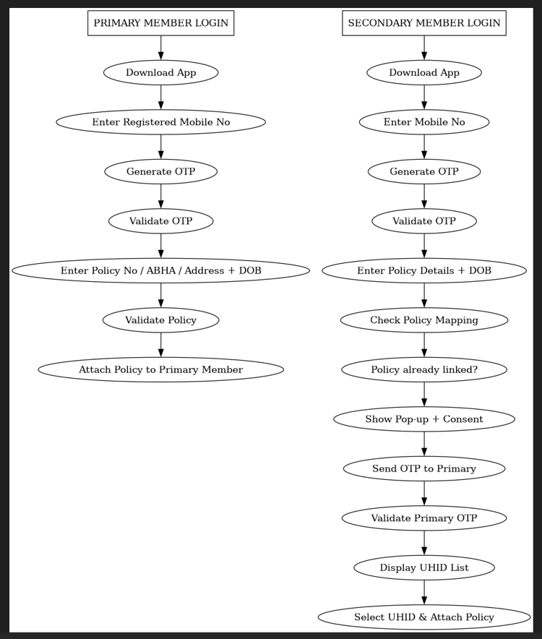

  - Relationship validation:

- The system shall allow reward point calculation only for adult insured members
- The system shall validate the member relationship before considering reward points.
- The system should not consider reward points earned by children.

  - More Option (Tenure Conversion Logic):

- The system shall identify when More Cover option is opted for a policy. Parameter to be pass to identify the cover is opted
- When More Cover is opted, the system shall fetch the revised policy tenure.
- The system shall update the policy end date based on the revised tenure.
- WYH shall calculate reward points based on the revised policy tenure.

  - Endorsement logic:

- When a new member is added via endorsement, PAS records Endorsement effective date to be considered and check for member relationship.
- The system starts reward eligibility only from endorsement effective date.
- The system starts reward eligibility only from endorsement effective date.

  - Cancel & Rebook – Reward Handling Options:
- The system shall not carry forward any reward points from the cancelled policy.
- The system shall reset the reward ledger for the new policy.
- In a Cancel & Rebook scenario, the system shall treat the new policy as a fresh policy.
- Reward points earned under a cancelled policy shall be carried forward in any rebooked policy.
- Reward points for the re-booked policy shall start only from the new policy inception date.
- Any reward activity done before the new policy start date shall be ignored.

  - Policy Fetch / Service Call Logic :

- Below fields to be consider to send data to WYH

Field | Source System | Remarks
Policy Number | HCS | Primary reference key
Start Date | HCS | Policy coverage start
End Date | HCS | Policy expiry
UHID | HCS | Unique Health ID
Renewal Flag | HCS | If TRUE → Renewal policy number required
Cancel & Rebooking Flag | PAS API | If TRUE → Fetch new policy against re-book policy
Cancel Status | PAS API | If YES → Policy inactive

  - Logic for calculation of rewards points at the time of renewal:

- WYH shall share the latest reward point balance with IGI on a daily basis. IGI shall use the received reward points to determine the applicable renewal discount based on the configured Discount Configuration Master.

- Upon receiving the daily reward point data from WYH, IGI shall validate below:

- Validate the policy details received from WYH.
- Retrieve the applicable discount slabs from the Discount Configuration Master.
- Match the available reward points against the configured discount slabs.
- Determine the applicable discount percentage or discount amount.
- Store the calculated discount for usage during renewal quotation and policy issuance.

- The system will generate a renewal notice 90 days prior to the policy expiry date.
- *The renewal communication may display the reward points available as of the renewal notice generation.
- At the time of renewal notice generation, the system to calculate and display an renewal discount based on the reward points available on the notice generation date.
- The customer may renew the policy at any time after the renewal notice is generated and before policy expiry.
- When the customer renewed policy then at the time of actual renewal transaction, the system shall recalculate the reward point balance as of the renewal transaction date.

- Example:

Policy Start Date | 01-01-2026
Policy End Date | 31-12-2026
Renewal Notice generation | 02-09-2026
Available Points at renewal generation | 4500
Renewal transaction date | 31-12-2026
Available Points at actual renewal generation | 7800

Month | Points
Jan-Sep | 4,500
Oct | 1,000
Nov | 1,100
Dec | 1,200
Total | 7,800

- The renewal discount shall be calculated using 7,800 points and not 4,500 points.

- Renewal After Policy Expiry (Grace Period)- If the customer renews the policy after the policy expiry date but within the allowed grace period, reward points earned during the grace period shall NOT be considered for renewal discount calculation.
- The reward points earned during the grace period shall be carried forward and made available in the next policy cycle.

- Example:

Policy End Date | 31-12-2026
Customer Renewal Date (Grace period) | 15-01-2027

Description | Points
Points till 31-Dec-2026 | 7800
Points earned during grace period | 300
Points eligible for renewal discount | 7800
Points carried forward to next cycle | 8100

- Refer Below calculation logic :

  - Reward Points Handling for Split Policy:

- The system shall consider the renewal notice generation date as the cut-off date for reward point calculation.
- For example, if the renewal notice date is 1st October, it shall be treated as the cut-off date.
- The system shall maintain and calculate reward points at the individual member level using a unique Member ID.
- Eligible and carry-forward points shall be computed separately for each member.
- During policy split, the system shall transfer carry-forward points of each member to the respective new policy based on member allocation.
- Carry-forward points shall not be duplicated.
- The system shall map each member to the new policy and assign their respective carry-forward points as follows:
- The system shall update the vendor (WYH) with:
- Member-to-policy mapping changes
- Carry-forward reward balances
- The system shall ensure consistency between internal records and vendor data.

  - Dashboard & MIS :
- WYH shall generate and share a daily reward point file/API containing the latest reward point balance for all active policies.
- The reward point balance shall include all points accrued up to the date of file generation.

- *Below parameters can be considered for report generation: (Tentative format need to confirm with business about column)

Policy Number
UHID
Policy Start Date
Policy End Date
Reward Points Earned Till Date
Reward Point Balance Available
Policy Status
Renewal Eligibility Flag
More cover opted

  - Reward Point Visibility in Selfi App:

The Selfi App shall provide customers with real-time visibility of their reward point status, enabling them to track both earned reward points

The system shall display the cumulative reward points earned by the customer as of the current date based on the reward point accrual schedule.

Available Reward Points : 4,500
Redeemed Points : 3500
Balance Points:1000

Current screen of dashboard:
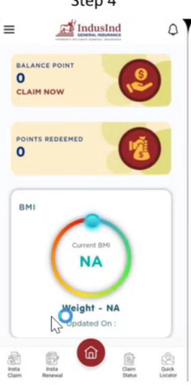

Compliance & Security

Requirements

Non-Functional Requirements

References

Requirement Question/ Clarifications Section

